Steps in Model Development:->
- Import the libraries
import piplite
await piplite.install('seaborn')

import pandas as pd
import matplotlib.pyplot as plt
import numpy as np
import seaborn as sns
from sklearn.pipeline import Pipeline
from sklearn.preprocessing import StandardScaler, PolynomialFeatures
from sklearn.linear_model import LinearRegression, Ridge
from sklearn.metrics import mean_squared_error, r2_score
from sklearn.model_selection import cross_val_score, train_test_split

- Download the dataset to the environment
i)
from pyodide.http import pyfetch

async def download(url, filename):
response = await pyfetch(url)
if response.status == 200:
with open(filename, "wb") as f:
f.write(await response.bytes())

ii) reading the filepath

filepath = 'https://cf-courses-data.s3.us.cloud-object-storage.appdomain.cloud/IBMDeveloperSkillsNetwork-DA0101EN-Coursera/medical_insurance_dataset.csv'

#Download the file
await download(filepath, "insurance.csv")
file_name="insurance.csv"

#No Headers in the CSV File
df = pd.read_csv(file_name, header = None)
df.head(5)

- Add Headers to the DataFrame
headers = ["age", "gender", "bmi", "no_of_children", "smoker", "region","charges"]
df.columns = headers

- Replacing the ? with Nan Entries:

df.replace('?', np.nan, inplace = True)

- Handle Missing Data

# smoker is a categorical attribute, replace with most frequent entry
is_smoker = df['smoker'].value_counts().idxmax()
df["smoker"].replace(np.nan, is_smoker, inplace=True)

# age is a continuous variable, replace with mean age
mean_age = df['age'].astype('float').mean(axis=0)
df["age"].replace(np.nan, mean_age, inplace=True)

# Update data types
df[["age","smoker"]] = df[["age","smoker"]].astype("int")

print(df.info())

- Round to 2 Decimal Places
df[["charges"]] = np.round(df[["charges"]],2)
print(df.head())

- Implement the regression plot

sns.regplot(x="bmi", y="charges", data=df, line_kws={"color": "red"})
plt.ylim(0,)

- Box Plot
sns.boxplot(x="smoker", y="charges", data=df)

- Correlation Matrix:
Df.corr()

- Linear Regression Model:
X = df[['smoker']]
Y = df['charges']
lm = LinearRegression()
lm.fit(X,Y)
print(lm.score(X, Y))

- Multiple Linear Regression
Z = df[["age", "gender", "bmi", "no_of_children", "smoker", "region"]]
lm.fit(Z,Y)
print(lm.score(Z, Y))

- Model refinement:
Splitting the data into training and testing data

x_train, x_test, y_train, y_test = train_test_split(Z, Y, test_size=0.2, random_state=1)

Ridge regression

RidgeModel=Ridge(alpha=0.1)
RidgeModel.fit(x_train, y_train)
yhat = RidgeModel.predict(x_test)
print(r2_score(y_test,yhat))

Ploynomial Transformation

pr = PolynomialFeatures(degree=2)
x_train_pr = pr.fit_transform(x_train)
x_test_pr = pr.transform(x_test)
RidgeModel.fit(x_train_pr, y_train)
y_hat = RidgeModel.predict(x_test_pr)
print(r2_score(y_test,y_hat))

- To find the correlation of numerical values with price

df_numeric = df.select_dtypes(include=[np.number])
df_numeric.corr()['price'].sort_values()
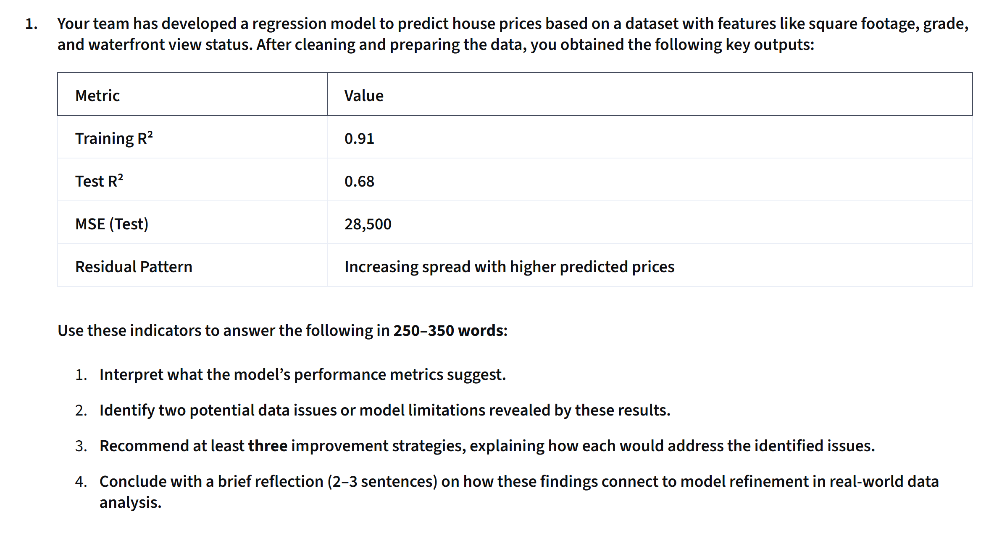

The house price regression model exhibits significant overfitting and heteroscedasticity. While the training $R^2$ is strong at 0.91, the test $R^2$ drops sharply to 0.68 with a Mean Squared Error (MSE) of 28,500. This variance indicates that the model fits noise in the training set rather than generalizing effectively. Additionally, the residual plot shows a fan-shaped pattern with an increasing spread at higher predicted prices, highlighting non-constant error variance.

These metrics reveal two primary limitations. First, overfitting occurs due to excess model complexity, collinear features, or noise capture. Second, heteroscedasticity arises because price variance naturally increases for higher-value properties, violating the homoscedasticity assumption of ordinary least squares (OLS) regression and making predictions for expensive homes unreliable.

To address these issues, three improvement strategies are recommended:

1. Target Transformation: Applying a logarithmic transformation ($\log(y)$) to house prices stabilizes variance, compressing higher-end values to resolve heteroscedasticity.

2. Regularization: Implementing Ridge or Lasso regression adds penalty terms to constrain large coefficients, penalizing complexity to reduce overfitting and narrow the gap between training and test $R^2$.

3. Feature Selection & Interaction: Removing multicollinear predictors and engineering meaningful non-linear features (e.g., polynomial terms or square footage interactions) captures true structural relationships without increasing model variance.

In real-world data analysis, diagnostic metrics like $R^2$ gaps and residual fan patterns serve as vital feedback loops. Model refinement is an iterative process where transforming variables and penalizing complexity ensure algorithms generalize effectively across all price segments rather than just memorizing training data.

